Packet Tracer – Troubleshooting a VLAN Implementation Scenario 2

1. Topology

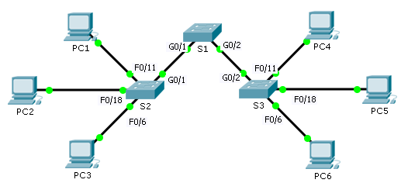

1. Addressing Table

|  |  |  |  |  |
| --- | --- | --- | --- | --- |
| Device | Interface | IPv4 Address | Subnet Mask | Default Gateway |
| S1 | VLAN 56 | 192.168.56.11 | 255.255.255.0 | N/A |
| S2 | VLAN 56 | 192.168.56.12 | 255.255.255.0 | N/A |
| S3 | VLAN 56 | 192.168.56.13 | 255.255.255.0 | N/A |
| PC1 | NIC | 192.168.10.21 | 255.255.255.0 | 192.168.10.1 |
| PC2 | NIC | 192.168.20.22 | 255.255.255.0 | 192.168.20.1 |
| PC3 | NIC | 192.168.30.23 | 255.255.255.0 | 192.168.30.1 |
| PC4 | NIC | 192.168.10.24 | 255.255.255.0 | 192.168.10.1 |
| PC5 | NIC | 192.168.20.25 | 255.255.255.0 | 192.168.20.1 |
| PC6 | NIC | 192.168.30.26 | 255.255.255.0 | 192.168.30.1 |

1. VLAN and Port Assignments

|  |  |  |
| --- | --- | --- |
| Ports | VLAN Number - Name | Network |
| F0/1 – F0/5 | VLAN 56 – Management&Native | 192.168.56.0/24 |
| F0/6 – F0/10 | VLAN 30 – Guest(Default) | 192.168.30.0/24 |
| F0/11 – F0/17 | VLAN 10 – Faculty/Staff | 192.168.10.0/24 |
| F0/18 – F0/24 | VLAN 20 – Students | 192.168.20.0/24 |

1. Objectives

Part 1: Find and Correct the Network Errors

Part 2: Document the Corrections to the Network

Part 3: Implement Solutions and Test Connectivity

1. Background

In this activity, you will troubleshoot a misconfigured VLAN environment. The initial network has errors. Your objective is to locate and correct the errors in the configurations and establish end-to-end connectivity. Your final configuration should match the Topology diagram and Addressing Table. The native VLAN for this topology is VLAN 56.

1. Discover and Document Issues in the Network

Use the Topology, Addressing Table, VLAN and Port Assignments table and your knowledge of VLANs and trunking to discover issues in the network. Complete the **Documentation** table listing the problems you discovered and potential solutions.

1. Documentation

|  |  |
| --- | --- |
| **Problems** | **Solutions** |
| S2 G0/1 is access port | Switchport mode trunk |
| S1 don’t have vlans | Assign vlans on S1 |
| S3 ports not assigned to vlans | Switchport access vlan x |
| Vlan mismatch | Configure trunk ports on S1 |
|  |  |
|  |  |

1. Implement the Solution and Test Connectivity

Verify PCs on the same VLAN can now ping each other. If not, continue to troubleshoot.

1. Suggested Scoring Rubric

Packet Tracer scores 70 points. Documentation in Part 2, Step 3 is worth 30 points.